**BUILD THE CHATBOT PROJECT BY LOADING AND PREPROCESSING DATASET USING PYTHON**

Building a chatbot project involves several steps, and loading and preprocessing the dataset is just one of them. Here's a high-level overview of how you can build a chatbot project using Python.

**BLOCK DIAGRAM FOR CHATBOT:**

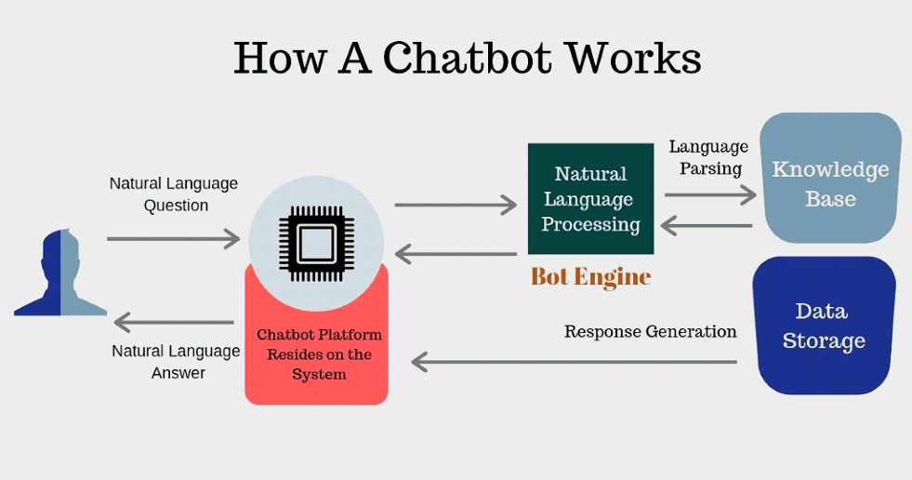

**TABLE OF CONTENTS:**

* Define the Goal and Scope.
* Gather or Generate Data.
* Preprocessing the dataset.
* Choose a Framework or library.
* Training the Chatbot.
* Implement the Chatbot.
* Testing and Evaluation.
* Continuous Improvement.
* Create Documentation.

**1. Define the Goal and Scope:**

Start by defining the purpose and scope of your chatbot. What is it supposed to do? Who is the target audience?

**2. Gather or Generate Data:**

You'll need a dataset for training your chatbot. This could be a collection of conversation data. If you don't have a suitable dataset, you might need to create one or use publicly available chat datasets.

**3. Preprocessing the dataset:**

Preprocessing is a crucial step. You may need to clean and structure your data. For chatbot training, the data often includes pairs of questions and answers. Common preprocessing steps include tokenization, lowercasing, and removing punctuation.

**4. Choose a Framework or library:**

Select a Python library or framework for building the chatbot. Some popular options include NLTK, spacy, or more advanced tools like Rasa or TensorFlow.

**5. Training the Chatbot:**

Depending on your chosen framework, you'll need to train your chatbot model. For rule-based chatbots, you might define patterns and responses manually. For machine learning-based chatbots, you'll train the model on your preprocessed data.

**6. Implement the Chatbot:**

Develop the chatbot application, which includes integrating it with a user interface or platform. This is where users will interact with the chatbot.

**7. Testing and Evaluation:**

Test your chatbot to ensure it responds correctly to user inputs. You can use metrics like accuracy, F1-score, or user satisfaction for evaluation.

**8. Continuous Improvement:**

Chatbots often need ongoing maintenance and improvement. Analyze user interactions to identify common issues and improve the chatbot's responses.

**9. Create Documentation:**

Finally, create documentation that describes your chatbot, its functionality, and how to use it. This can include the preprocessing steps, model details, and deployment instructions.

**LIBRARIES AND FRAME WORKS:**

There are several libraries and frameworks commonly used to develop chatbots in Python, each with its own features and capabilities. Here are some of the most popular ones:

* **NLTK (Natural Language Toolkit):**

NLTK is a comprehensive library for natural language processing. While it doesn't provide pre-built chatbot functionality, you can use it to build rule-based chatbots from scratch.

* **spacy:**

spacy is another NLP library that's highly efficient and offers support for various NLP tasks. You can use spacy in combination with other libraries to develop chatbots.

* **Rasa:**

Rasa is an open-source conversational AI framework. It's designed specifically for building chatbots and virtual assistants. Rasa offers both rule-based and machine learning-based approaches

* **Chatterbot:**

Chatterbot is a Python library for building chatbots using machine learning. It's relatively simple to get started with and offers various training and language support.

* **TensorFlow and keras:**

These deep learning frameworks can be used to create custom chatbot models. You can train sequence-to-sequence models or transformer models for chatbot conversations.

* **GPT-3 (OpenAI's GPT-3):**

While not a Python library, GPT-3 is a powerful language model that can be accessed via API for chatbot development. It's capable of generating human-like responses.

* **Facebook's PyTorch-based models:**

Facebook's pyTorch-based models like BERT, T5, and others can be used for NLP tasks, including chatbot development.

* **Dialog flow (formerly API.AI):**

Dialog flow is a cloud-based NLP platform provided by Google. It offers an easy way to build chatbots using predefined intents and entities.

* **Microsoft Bot Framework:**

Microsoft provides a framework for building chatbots that can be deployed on various platforms, including Skype, Microsoft Teams, and more.

* **Bot Press:**

Bot Press is an open-source platform for building chatbots with a focus on enterprise-level functionality. It provides a visual interface for creating chatbots.

The choice of library or framework depends on your specific project requirements, including the complexity of the chatbot, the amount of training data available, and the platforms where you plan to deploy it. You can choose a library that best suits your needs and expertise.

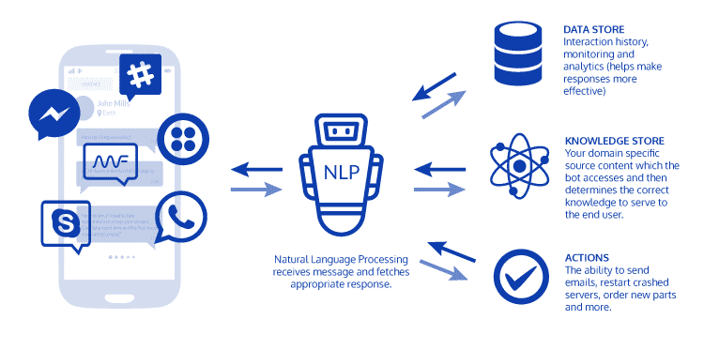

**BASIC CHATBOT USING PYTHON AND NLTK STEPS:**

* Install required libraries
* Import libraries

**1.INSTALL REQUIRED LIBRARIES:**

Ensure you have the NLTK library installed. you can install it using pip:

|  |
| --- |
| **pip install nltk** |

**2.IMPORT LIBRARIES:**

Import the necessary libraries in your python program.

|  |
| --- |
| **import nltk**  **from nltk.chat.util import Chat, reflections** |

**Python:**

import nltk

from nltk.chat.util import Chat, reflections

pairs = [

[

r "my name is (. *)",

["Hello %1, how can I help you today?",]

],

]

def chatbot ():

print ("Hello! I'm a simple chatbot. Type 'exit' to end the conversation.")

chat = Chat (pairs, reflections)

chat. Converse ()

if _ _name_ _ == "_ _main_ _":

chatbot ()

**Conclusion:**

Developing a chatbot can be a challenging but rewarding project, and Python provides a wide range of tools and libraries to help you get started. The key is to tailor your chatbot to meet your specific objectives and continuously work on refining its capabilities to provide value to users.